Power Bi :-
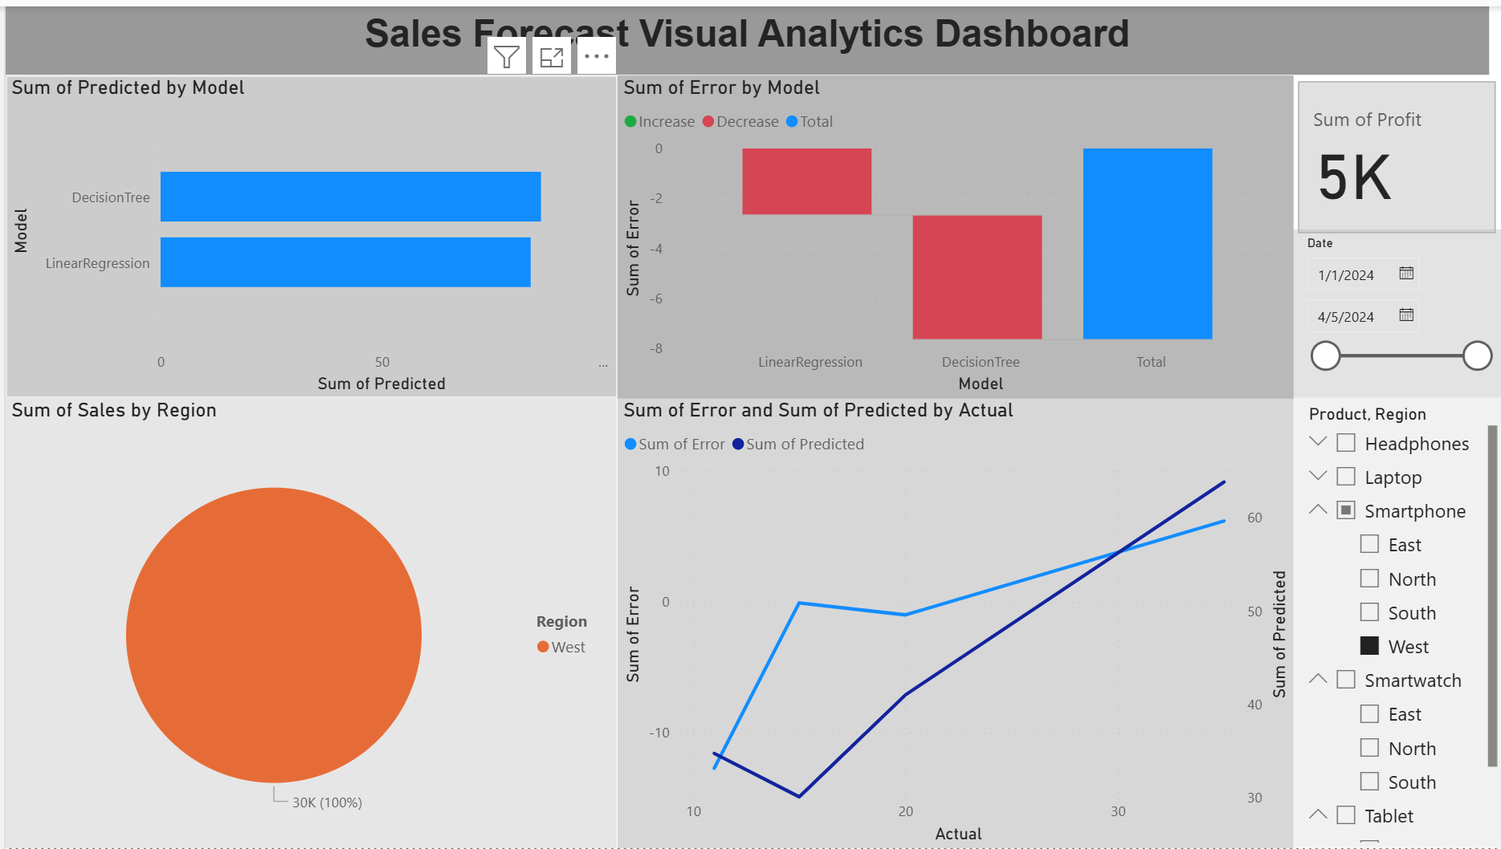

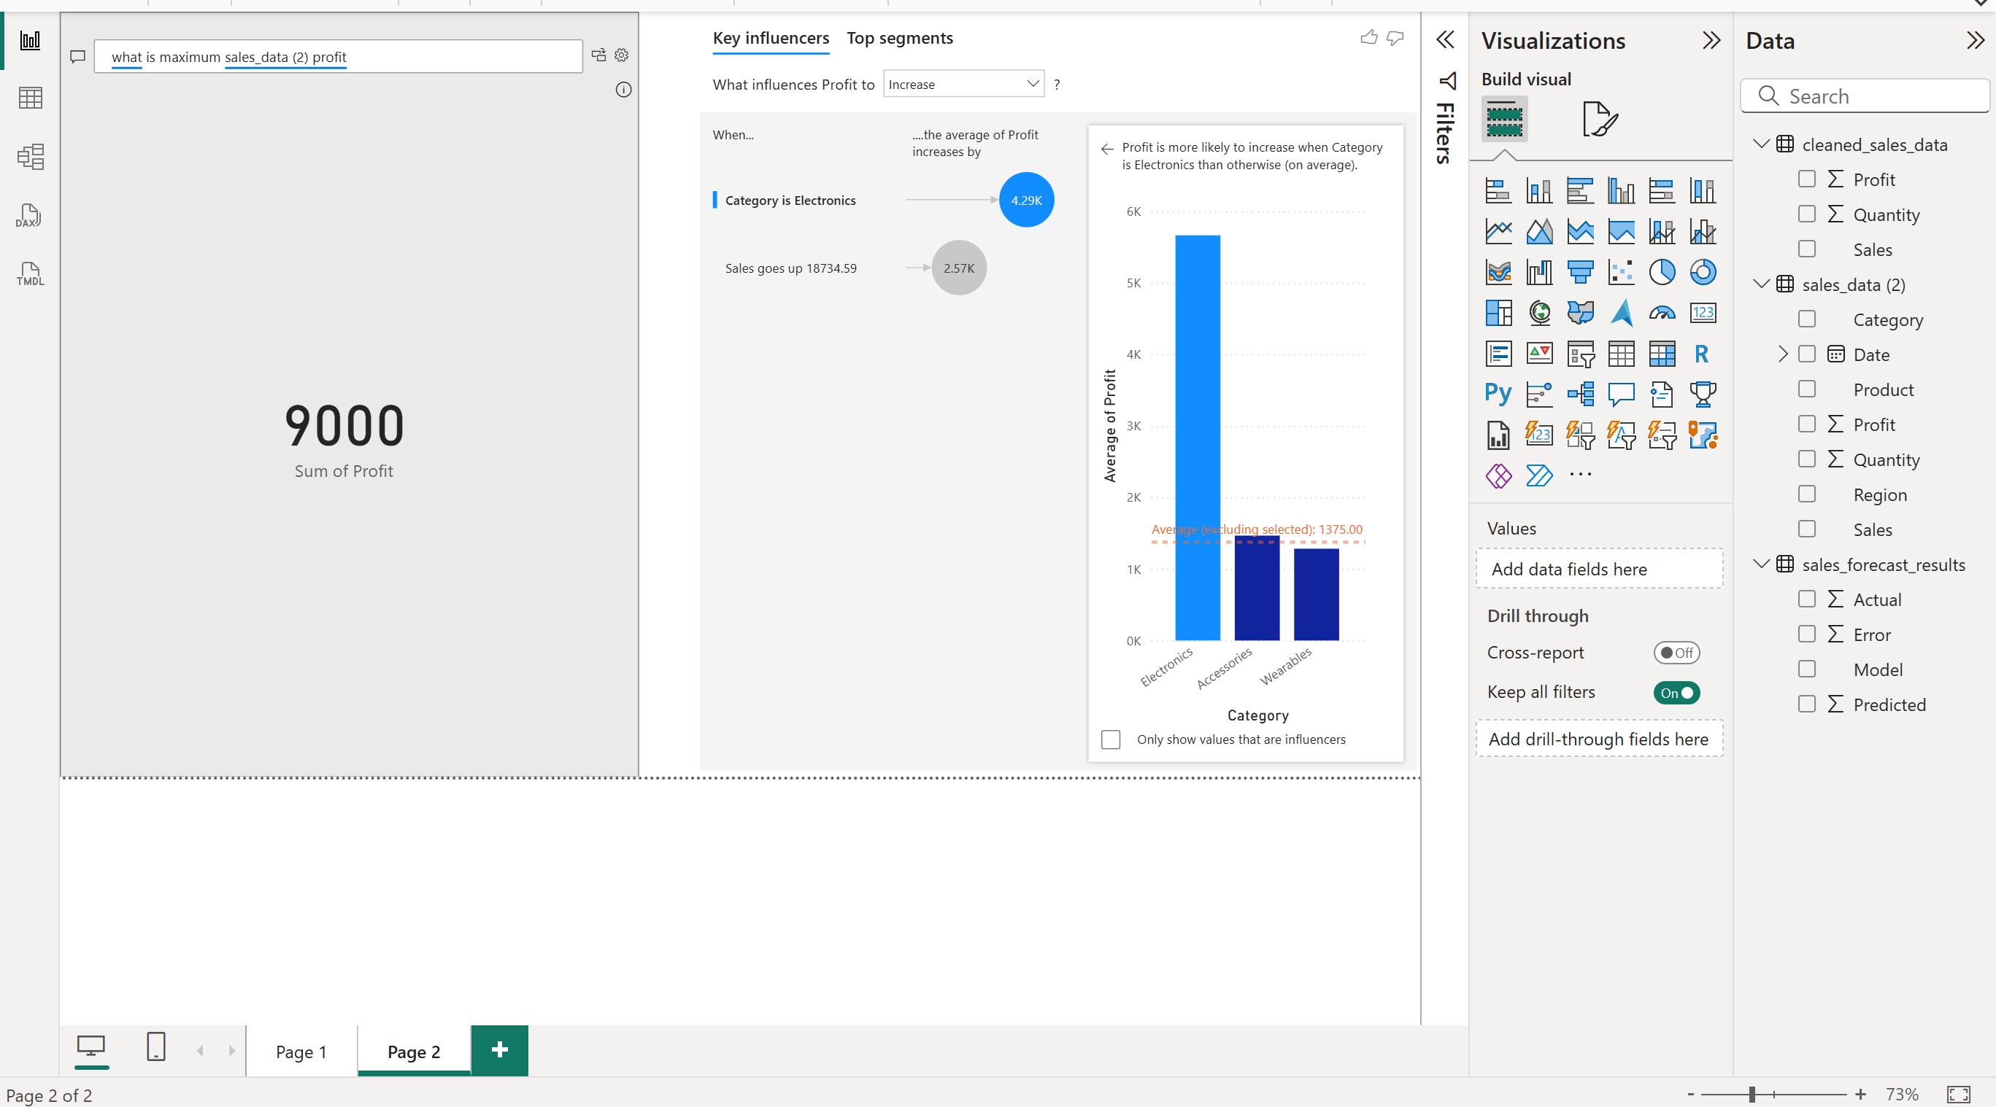

Streamlit Link :- https://sales-analytics-lab-5ud4e8vbmsyzzprvjgualr.streamlit.app/
Github link :- https://github.com/PranjalAmbwani1305/sales-analytics-lab/tree/main

Docker Image :-
